**FINOLEX ACADEMY OF MANAGEMENT AND TECHNOLOGY, RATNAGIRI**

**DEPARTMENT OF MCA**

**PRACTICAL NO. 04**

**Session Management and AJAX**

**Global.asax.cs**

using System;

using System.Collections.Generic;

using System.Linq;

using System.Web;

using System.Web.Security;

using System.Web.SessionState;

namespace PracticalNo4

{

public class Global : System.Web.HttpApplication

{

protected void Application_Start(object sender, EventArgs e)

{

Application["SiteVisiterCounter"] = 0;

Application["OnlineUserCounter"] = 0;

}

protected void Session_Start(object sender, EventArgs e)

{

Application.Lock();

Application["SiteVisiterCounter"] = Convert.ToInt32(Application["SiteVisiterCounter"]) + 1;

Application["OnlineUserCounter"] = Convert.ToInt32(Application["OnlineUserCounter"]) + 1;

Application.UnLock();

}

protected void Session_End(object sender, EventArgs e)

{

Application.Lock();

Application["OnlineUserCounter"] = Convert.ToInt32(Application["OnlineUserCounter"]) - 1;

Application.UnLock();

}

}

}

1. **Design Web application to maintain the session data using In-proc session state.**

**Ans:**

* **CODE –**

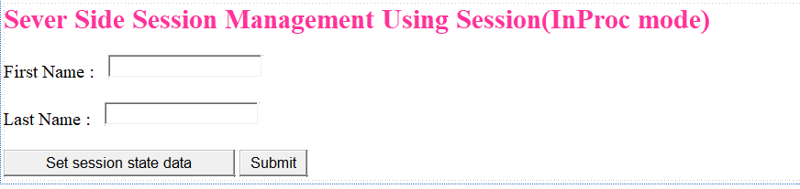**SM_SessionDemo1.aspx**

<%@ Page Language="C#" AutoEventWireup="true" CodeBehind="SM_SessionDemo1.aspx.cs" Inherits="PracticalNo4.SM_SessionDemo1" %>

<!DOCTYPE html>

<html xmlns="http://www.w3.org/1999/xhtml">

<head runat="server">

<title></title>

</head>

<body>

<form id="form1" runat="server">

<div>

<div>

<asp:Label ID="Label1" runat="server" Font-Bold="True" Font-Italic="False" Font-Size="X-Large" ForeColor="#FF3399" Text="Sever Side Session Management Using Session(InProc mode)"></asp:Label>

<br />

<br />

<asp:Label ID="lblFirstName" runat="server" Text="First Name : "></asp:Label>

&nbsp;

<asp:TextBox ID="txtFirstName" runat="server"></asp:TextBox>

<br />

<br />

<asp:Label ID="lblLastName" runat="server" Text="Last Name : "></asp:Label>

&nbsp;

<asp:TextBox ID="txtLastName" runat="server"></asp:TextBox>

<br />

<br />

<asp:Button ID="btnSetSessionState" runat="server" OnClick="btnSetSessionState_click" Text="Set session state data" Width="252px" />

&nbsp;<asp:Button ID="btnSubmit1" runat="server" OnClick="btnSubmit1_Click" Text="Submit" />

</div>

</div>

</form>

</body>

</html>

**SM_SessionDemo1.aspx.cs**

using System;

using System.Collections.Generic;

using System.Linq;

using System.Web;

using System.Web.UI;

using System.Web.UI.WebControls;

namespace PracticalNo4

{

public partial class SM_SessionDemo1 : System.Web.UI.Page

{

protected void Page_Load(object sender, EventArgs e)

{

}

protected void btnSetSessionState_click(object sender, EventArgs e)

{

Session["FirstName"] = txtFirstName.Text;

Session["LastName"] = txtLastName.Text;

}

protected void btnSubmit1_Click(object sender, EventArgs e)

{

Response.Redirect("SM_SessionDemo2.aspx");

}

}

}**SM_SessionDemo2.aspx**

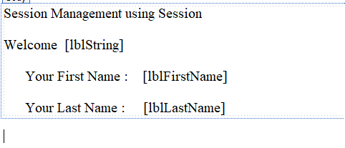

<%@ Page Language="C#" AutoEventWireup="true" CodeBehind="SM_SessionDemo2.aspx.cs" Inherits="PracticalNo4.SM_SessionDemo2" %>

<!DOCTYPE html>

<html xmlns="http://www.w3.org/1999/xhtml">

<head runat="server">

<title>Session State</title>

</head>

<body>

<form id="form1" runat="server">

<div>

<div>

<asp:Label ID="Label1" runat="server" Text="Session Management using Session"></asp:Label>

<br />

<br />

<asp:Label ID="Label2" runat="server" Text="Welcome"></asp:Label>

&nbsp;

<asp:Label ID="lblString" runat="server"></asp:Label>

<br />

<br />

&nbsp;&nbsp;&nbsp;&nbsp;&nbsp;

<asp:Label ID="Label3" runat="server" Text="Your First Name : "></asp:Label>

&nbsp;&nbsp;

<asp:Label ID="lblFirstName" runat="server"></asp:Label>

<br />

<br />

&nbsp;&nbsp;&nbsp;&nbsp;&nbsp;

<asp:Label ID="Label4" runat="server" Text="Your Last Name : "></asp:Label>

&nbsp;&nbsp;&nbsp;

<asp:Label ID="lblLastName" runat="server"></asp:Label>

</div>

</div>

</form>

</body>

</html>

**SM_SessionDemo2.aspx.cs**

using System;

using System.Collections.Generic;

using System.Linq;

using System.Web;

using System.Web.UI;

using System.Web.UI.WebControls;

namespace PracticalNo4

{

public partial class SM_SessionDemo2 : System.Web.UI.Page

{

protected void Page_Load(object sender, EventArgs e)

{

if (!IsPostBack)

{

if (Session["FirstName"] != null && Session["LastName"] != null)

{

lblString.Text = Session["FirstName"].ToString();

lblFirstName.Text = Session["FirstName"].ToString();

lblLastName.Text = Session["LastName"].ToString();

}

else

{

lblFirstName.Text = "Session for FirstName key is not set!!";

lblLastName.Text = "Session for LastName key is not set!!";

}

}

}

}

}

**Web.config**

<!--Inproc-->

<sessionState mode="InProc" timeout="1"></sessionState>

* **OUTPUT :**

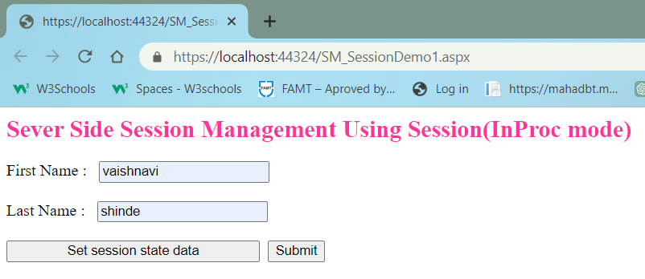

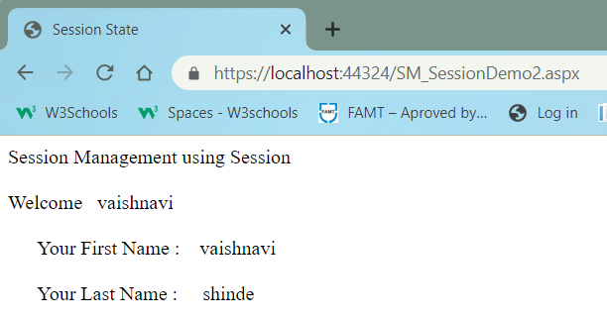

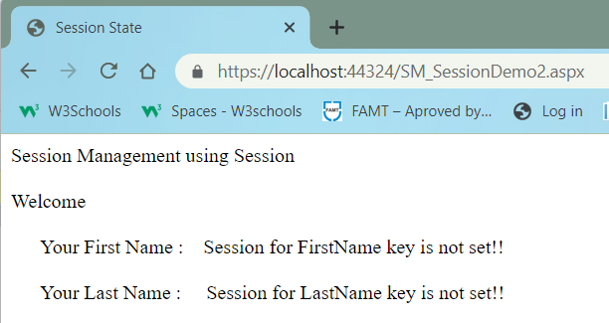

**2. Design Web application to maintain the session data using Out of process session state (UseStateServer and SQLServer modes).**

**Ans:**

* **CODE –**

**1)StateServer Mode –**

**SM_SessionDemo1.aspx**

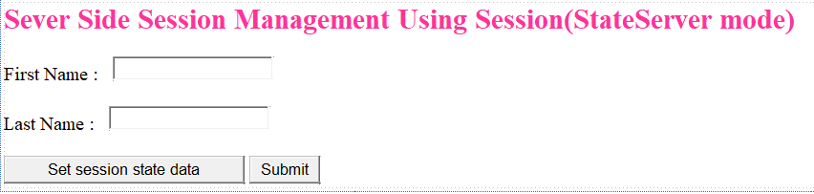

<%@ Page Language="C#" AutoEventWireup="true" CodeBehind="SM_SessionDemo1.aspx.cs" Inherits="PracticalNo4.SM_SessionDemo1" %>

<!DOCTYPE html>

<html xmlns="http://www.w3.org/1999/xhtml">

<head runat="server">

<title></title>

</head>

<body>

<form id="form1" runat="server">

<div>

<div>

<asp:Label ID="Label1" runat="server" Font-Bold="True" Font-Italic="False" Font-Size="X-Large" ForeColor="#FF3399" Text="Sever Side Session Management Using Session(StateServer mode)"></asp:Label>

<br />

<br />

<asp:Label ID="lblFirstName" runat="server" Text="First Name : "></asp:Label>

&nbsp;

<asp:TextBox ID="txtFirstName" runat="server"></asp:TextBox>

<br />

<br />

<asp:Label ID="lblLastName" runat="server" Text="Last Name : "></asp:Label>

&nbsp;

<asp:TextBox ID="txtLastName" runat="server"></asp:TextBox>

<br />

<br />

<asp:Button ID="btnSetSessionState" runat="server" OnClick="btnSetSessionState_click" Text="Set session state data" Width="252px" />

&nbsp;<asp:Button ID="btnSubmit1" runat="server" OnClick="btnSubmit1_Click" Text="Submit" />

</div>

</div>

</form>

</body>

</html>

**SM_SessionDemo1.aspx.cs**

using System;

using System.Collections.Generic;

using System.Linq;

using System.Web;

using System.Web.UI;

using System.Web.UI.WebControls;

namespace PracticalNo4

{

public partial class SM_SessionDemo1 : System.Web.UI.Page

{

protected void Page_Load(object sender, EventArgs e)

{

}

protected void btnSubmit_Click(object sender, EventArgs e)

{

Session["FirstName"] = txtFirstName.Text;

Session["LastName"] = txtLastName.Text;

Response.Redirect("SM_SessionDemo2.aspx");

}

}

}

**SM_SessionDemo2.aspx**



<%@ Page Language="C#" AutoEventWireup="true" CodeBehind="SM_SessionDemo2.aspx.cs" Inherits="PracticalNo4.SM_SessionDemo2" %>

<!DOCTYPE html>

<html xmlns="http://www.w3.org/1999/xhtml">

<head runat="server">

<title>Session State</title>

</head>

<body>

<form id="form1" runat="server">

<div>

<div>

<asp:Label ID="Label1" runat="server" Text="Session Management using Session"></asp:Label>

<br />

<br />

<asp:Label ID="Label2" runat="server" Text="Welcome"></asp:Label>

&nbsp;

<asp:Label ID="lblString" runat="server"></asp:Label>

<br />

<br />

&nbsp;&nbsp;&nbsp;&nbsp;&nbsp;

<asp:Label ID="Label3" runat="server" Text="Your First Name : "></asp:Label>

&nbsp;&nbsp;

<asp:Label ID="lblFirstName" runat="server"></asp:Label>

<br />

<br />

&nbsp;&nbsp;&nbsp;&nbsp;&nbsp;

<asp:Label ID="Label4" runat="server" Text="Your Last Name : "></asp:Label>

&nbsp;&nbsp;&nbsp;

<asp:Label ID="lblLastName" runat="server"></asp:Label>

</div>

</div>

</form>

</body>

</html>

**SM_SessionDemo2.aspx.cs**

using System;

using System.Collections.Generic;

using System.Linq;

using System.Web;

using System.Web.UI;

using System.Web.UI.WebControls;

namespace PracticalNo4

{

public partial class SM_SessionDemo2 : System.Web.UI.Page

{

protected void Page_Load(object sender, EventArgs e)

{

if (!IsPostBack)

{

if (Session["FirstName"] != null && Session["LastName"] != null)

{

lblString.Text = Session["FirstName"].ToString();

lblFirstName.Text = Session["FirstName"].ToString();

lblLastName.Text = Session["LastName"].ToString();

}

else

{

lblFirstName.Text = "Session for FirstName key is not set!!";

lblLastName.Text = "Session for LastName key is not set!!";

}

}

}

}

}

**Web.config**

<!--StateServer-->

<sessionState mode="StateServer" stateConnectionString="tcpip=127.0.0.1:42424" stateNetworkTimeout="10" timeout="1"/>

* **OUTPUT :**

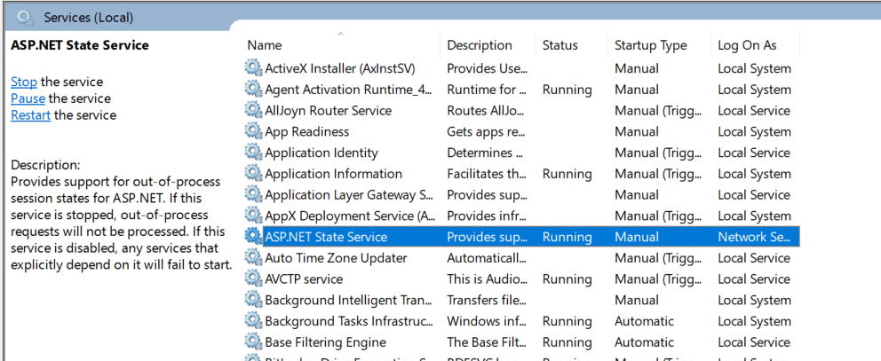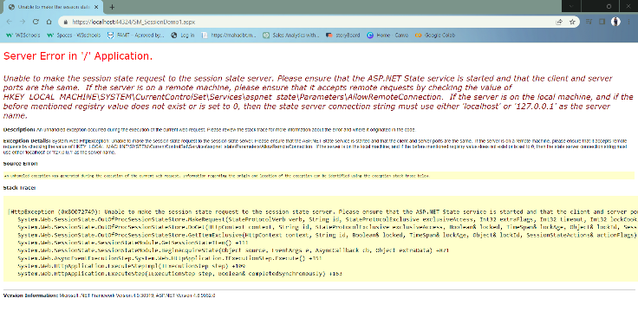

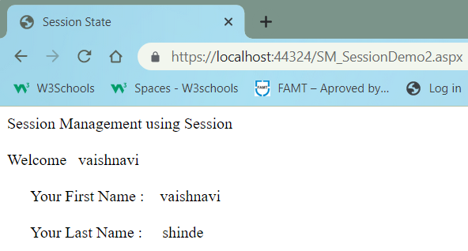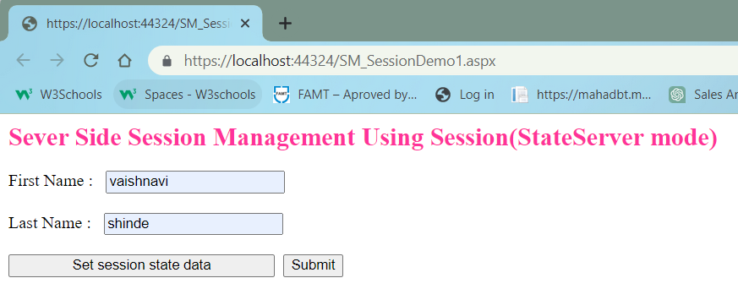

2)SQLServer Mode –

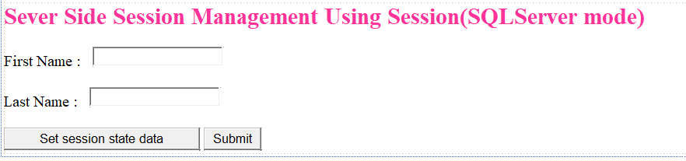**SM_SessionDemo1.aspx**

<%@ Page Language="C#" AutoEventWireup="true" CodeBehind="SM_SessionDemo1.aspx.cs" Inherits="PracticalNo4.SM_SessionDemo1" %>

<!DOCTYPE html>

<html xmlns="http://www.w3.org/1999/xhtml">

<head runat="server">

<title></title>

</head>

<body>

<form id="form1" runat="server">

<div>

<div>

<asp:Label ID="Label1" runat="server" Font-Bold="True" Font-Italic="False" Font-Size="X-Large" ForeColor="#FF3399" Text="Sever Side Session Management Using Session(SQLServer mode)"></asp:Label>

<br />

<br />

<asp:Label ID="lblFirstName" runat="server" Text="First Name : "></asp:Label>

&nbsp;

<asp:TextBox ID="txtFirstName" runat="server"></asp:TextBox>

<br />

<br />

<asp:Label ID="lblLastName" runat="server" Text="Last Name : "></asp:Label>

&nbsp;

<asp:TextBox ID="txtLastName" runat="server"></asp:TextBox>

<br />

<br />

<asp:Button ID="btnSetSessionState" runat="server" OnClick="btnSetSessionState_click" Text="Set session state data" Width="252px" />

&nbsp;<asp:Button ID="btnSubmit1" runat="server" OnClick="btnSubmit1_Click" Text="Submit" />

</div>

</div>

</form>

</body>

</html>

**SM_SessionDemo1.aspx.cs**

using System;

using System.Collections.Generic;

using System.Linq;

using System.Web;

using System.Web.UI;

using System.Web.UI.WebControls;

namespace PracticalNo4

{

public partial class SM_SessionDemo1 : System.Web.UI.Page

{

protected void Page_Load(object sender, EventArgs e)

{

}

protected void btnSubmit_Click(object sender, EventArgs e)

{

Session["FirstName"] = txtFirstName.Text;

Session["LastName"] = txtLastName.Text;

Response.Redirect("SM_SessionDemo2.aspx");

}

}

}

**SM_SessionDemo2.aspx**



<%@ Page Language="C#" AutoEventWireup="true" CodeBehind="SM_SessionDemo2.aspx.cs" Inherits="PracticalNo4.SM_SessionDemo2" %>

<!DOCTYPE html>

<html xmlns="http://www.w3.org/1999/xhtml">

<head runat="server">

<title>Session State</title>

</head>

<body>

<form id="form1" runat="server">

<div>

<div>

<asp:Label ID="Label1" runat="server" Text="Session Management using Session"></asp:Label>

<br />

<br />

<asp:Label ID="Label2" runat="server" Text="Welcome"></asp:Label>

&nbsp;

<asp:Label ID="lblString" runat="server"></asp:Label>

<br />

<br />

&nbsp;&nbsp;&nbsp;&nbsp;&nbsp;

<asp:Label ID="Label3" runat="server" Text="Your First Name : "></asp:Label>

&nbsp;&nbsp;

<asp:Label ID="lblFirstName" runat="server"></asp:Label>

<br />

<br />

&nbsp;&nbsp;&nbsp;&nbsp;&nbsp;

<asp:Label ID="Label4" runat="server" Text="Your Last Name : "></asp:Label>

&nbsp;&nbsp;&nbsp;

<asp:Label ID="lblLastName" runat="server"></asp:Label>

</div>

</div>

</form>

</body>

</html>

**SM_SessionDemo2.aspx.cs**

using System;

using System.Collections.Generic;

using System.Linq;

using System.Web;

using System.Web.UI;

using System.Web.UI.WebControls;

namespace PracticalNo4

{

public partial class SM_SessionDemo2 : System.Web.UI.Page

{

protected void Page_Load(object sender, EventArgs e)

{

if (!IsPostBack)

{

if (Session["FirstName"] != null && Session["LastName"] != null)

{

lblString.Text = Session["FirstName"].ToString();

lblFirstName.Text = Session["FirstName"].ToString();

lblLastName.Text = Session["LastName"].ToString();

}

else

{

lblFirstName.Text = "Session for FirstName key is not set!!";

lblLastName.Text = "Session for LastName key is not set!!";

}

}

}

}

}

**Web.config**

<!--SQLServer-->

<sessionState mode="SQLServer" sqlConnectionString="Data Source=(LocalDB)\MSSQLLocalDB;Integrated Security=SSPI"

cookieless="true"

regenerateExpiredSessionId="true"

stateNetworkTimeout="40" timeout="1"></sessionState>

* **OUTPUT :**

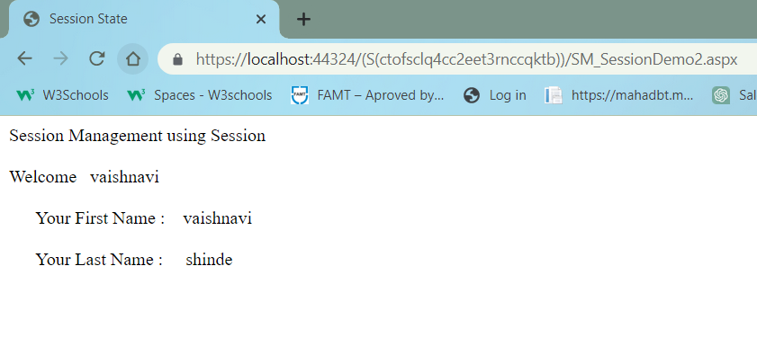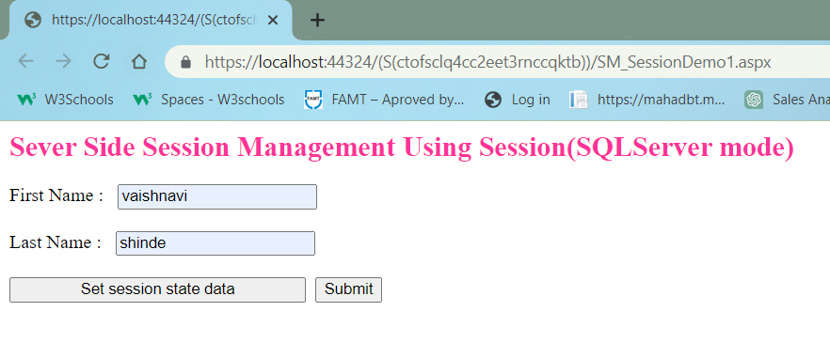

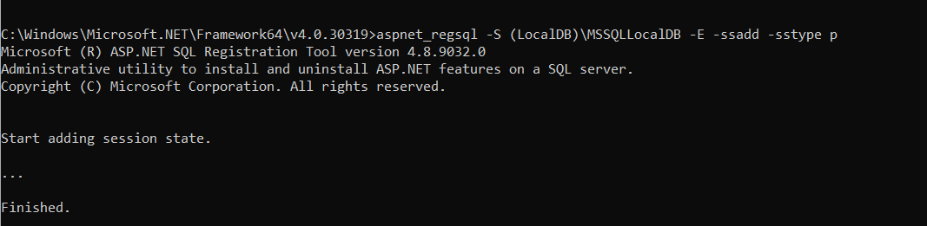



**3. Design an ASP.NET web application to display the number of times current page is visited using following session management techniques:**

**a. View State**

**b. QueryString**

**c. Cookies and**

**d. Application State**

**Ans:**

* **CODE –**

1. **View State**

**SM_ViewState.aspx**

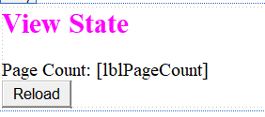

<%@ Page Language="C#" AutoEventWireup="true" CodeBehind="SM_ViewState.aspx.cs" Inherits="PracticalNo4.SM_ViewState" %>

<!DOCTYPE html>

<html xmlns="http://www.w3.org/1999/xhtml">

<head runat="server">

<title></title>

</head>

<body>

<form id="form1" runat="server">

<div>

<div>

<asp:Label ID="Label2" runat="server" Font-Bold="True" Font-Size="X-Large" ForeColor="Fuchsia" Text="View State"></asp:Label>

<br />

<br />

<asp:Label ID="Label1" runat="server" Text="Page Count: "></asp:Label>

<asp:Label ID="lblPageCount" runat="server"></asp:Label>

<br />

<asp:Button ID="btnReload" runat="server" OnClick="btnReload_Click" Text="Reload" />

</div>

</div>

</form>

</body>

</html>

**SM_ViewState.aspx.cs**

using System;

using System.Collections.Generic;

using System.Linq;

using System.Web;

using System.Web.UI;

using System.Web.UI.WebControls;

namespace PracticalNo4

{

public partial class SM_ViewState : System.Web.UI.Page

{

protected void Page_Load(object sender, EventArgs e)

{

}

protected void btnReload_Click(object sender, EventArgs e)

{

int Count = 0;

if (ViewState["Counter"] == null)

Count += 1;

else

Count = ((int)ViewState["Counter"]) + 1;

ViewState["Counter"] = Count;

lblPageCount.Text = Count.ToString();

}

}

}

* **OUTPUT :**

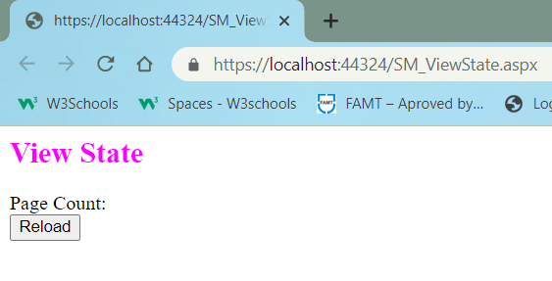

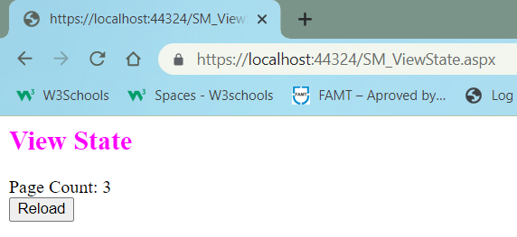

**b. QueryString**

* **CODE –**

**SM_QueryString.aspx**

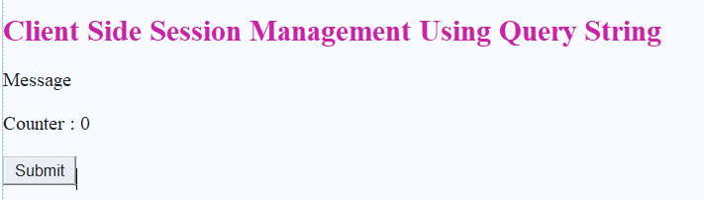

<%@ Page Language="C#" AutoEventWireup="true" CodeBehind="SM_QueryString.aspx.cs" Inherits="PracticalNo4.SM_QueryString" %>

<!DOCTYPE html>

<html xmlns="http://www.w3.org/1999/xhtml">

<head runat="server">

<title>Query String</title>

</head>

<body>

<form id="form1" runat="server">

<div>

<br />

<asp:Label ID="Label1" runat="server" Font-Bold="True" Font-Size="X-Large" ForeColor="#CC0099" Text="Client Side Session Management Using Query String"></asp:Label>

<br />

<br />

<asp:Label ID="lblMessage" runat="server" Text="Message"></asp:Label>

<br />

<br />

<asp:Label ID="Label3" runat="server" Text="Counter : "></asp:Label>

<asp:Label ID="lblCounter" runat="server" Text="0"></asp:Label>

<br />

<br />

<asp:Button ID="btnSubmit" runat="server" OnClick="btnSubmit_Click" Text="Submit" />

<br />

<br />

</div>

</form>

</body>

</html>

**SM_QueryString.aspx.cs**

using System;

using System.Collections.Generic;

using System.Linq;

using System.Web;

using System.Web.UI;

using System.Web.UI.WebControls;

namespace PracticalNo4

{

public partial class SM_QueryString : System.Web.UI.Page

{

int cnt;

protected void Page_Load(object sender, EventArgs e)

{

cnt = Convert.ToInt32(Server.UrlDecode(Request.QueryString["count"]));

if(cnt !=0)

{

cnt = cnt + 1;

}

else

{

cnt = 1;

}

lblCounter.Text = Convert.ToString(cnt);

lblMessage.Text = "Welcome" + Request.QueryString["name"];

}

protected void btnSubmit_Click(object sender, EventArgs e)

{

Response.Redirect("SM_QueryString.aspx?count=" + Server.UrlEncode(lblCounter.Text) + "&&name=Vaishnavi");

}

}

}

* **OUTPUT :**

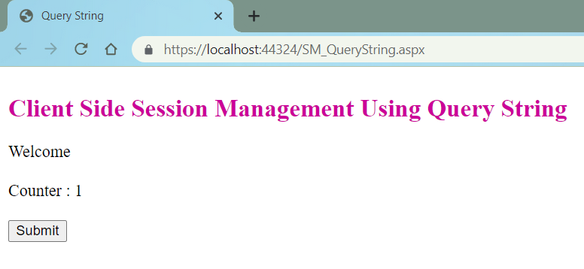

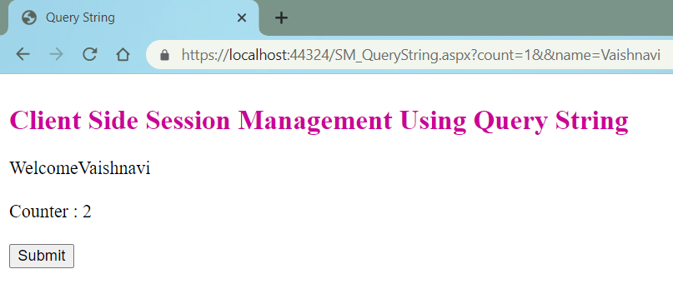

**c. Cookies**

* **CODE –**

**SM_Cookies.aspx**

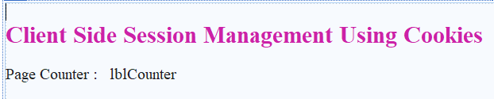

<%@ Page Language="C#" AutoEventWireup="true" CodeBehind="SM_Cookies.aspx.cs" Inherits="PracticalNo4.SM_Cookies" %>

<!DOCTYPE html>

<html xmlns="http://www.w3.org/1999/xhtml">

<head runat="server">

<title>Cookies</title>

</head>

<body>

<form id="form1" runat="server">

<div>

<br />

<asp:Label ID="Label1" runat="server" Font-Bold="True" Font-Size="X-Large" ForeColor="#CC0099" Text="Client Side Session Management Using Cookies"></asp:Label>

<br />

<br />

<asp:Label ID="Label2" runat="server" Text="Page Counter : "></asp:Label>

&nbsp;

<asp:Label ID="lblCounter" runat="server" Text="lblCounter"></asp:Label>

<br />

<br />

</div>

</form>

</body>

</html>

**SM_Cookies.aspx.cs**

using System;

using System.Collections.Generic;

using System.Linq;

using System.Web;

using System.Web.UI;

using System.Web.UI.WebControls;

namespace PracticalNo4

{

public partial class SM_Cookies : System.Web.UI.Page

{

int counter = 0;

protected void Page_Load(object sender, EventArgs e)

{

if(Request.Cookies["counter"] == null)

{

counter = 1;

}

else

{

counter = int.Parse(Request.Cookies["counter"].Value) + 1;

}

Response.Cookies["counter"].Value = counter.ToString();

// Response.Cookies["counter"].Expires = DateTime.Now.AddSeconds(5);

if(Request.Cookies["counter"] != null)

{

lblCounter.Text = Request.Cookies["counter"].Value;

}

}

}

}

**Web.config**

<!--Cookies-->

<sessionState cookieless="AutoDetect" regenerateExpiredSessionId="true" ></sessionState>

* **OUTPUT :**

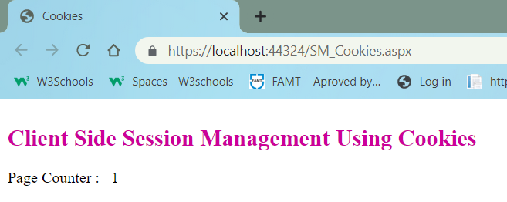

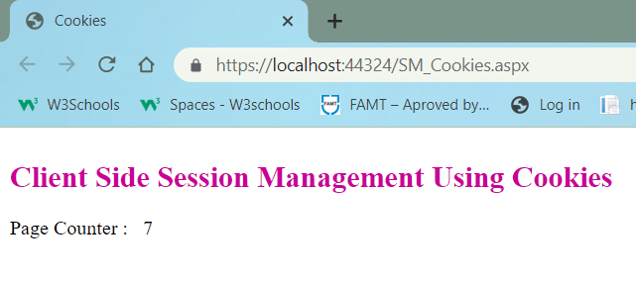

**d. Application State**

* **CODE –**

**SM_ApplicationState.aspx**

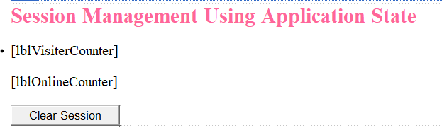

<%@ Page Language="C#" AutoEventWireup="true" CodeBehind="SM_ApplicationState.aspx.cs" Inherits="PracticalNo4.SM_ApplicationState" %>

<!DOCTYPE html>

<html xmlns="http://www.w3.org/1999/xhtml">

<head runat="server">

<title></title>

</head>

<body>

<form id="form1" runat="server">

<div>

<asp:Label ID="Label1" runat="server" Font-Bold="True" Font-Size="X-Large" ForeColor="#FF6699" Text="Session Management Using Application State"></asp:Label>

<br />

<br />

<asp:Label ID="lblVisiterCounter" runat="server"></asp:Label>

<br />

<br />

<asp:Label ID="lblOnlineCounter" runat="server"></asp:Label>

<br />

<br />

<asp:Button ID="btnClearSession" runat="server" Text="Clear Session" OnClick="btnClearSession_Click" />

</div>

</form>

</body>

</html>

**SM_ApplicationState.aspx.cs**

using System;

using System.Collections.Generic;

using System.Linq;

using System.Web;

using System.Web.UI;

using System.Web.UI.WebControls;

namespace PracticalNo4

{

public partial class SM_ApplicationState : System.Web.UI.Page

{

protected void Page_Load(object sender, EventArgs e)

{

lblVisiterCounter.Text = "No of times site visited = "+(Application["SiteVisiterCounter"]).ToString();

lblOnlineCounter.Text = "No of users online on the site = " + (Application["OnlineUserCounter"]).ToString();

}

protected void btnClearSession_Click(object sender, EventArgs e)

{

Session.Abandon();

}

}

}

* 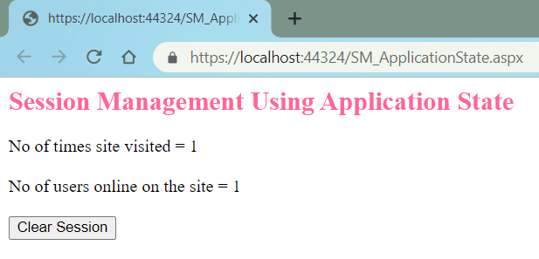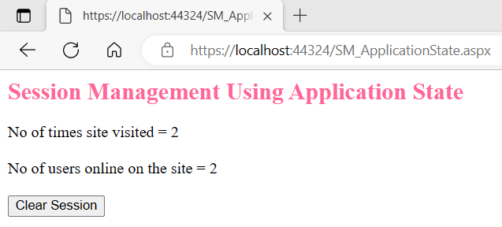**OUTPUT :**

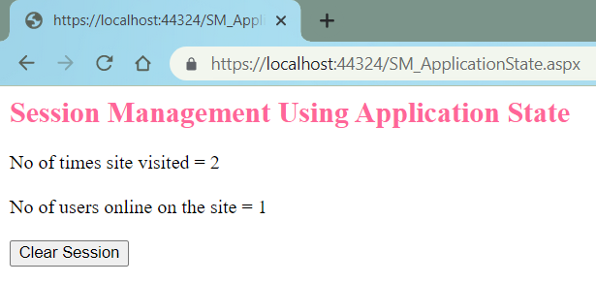

**4. Design an ASP.NET web form to display digital clock using AJAX.**

**Ans:**

* **CODE –**

**WF_DigitalClock_AJAX.aspx**

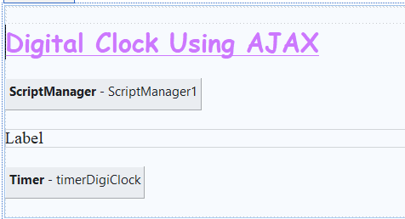

<%@ Page Language="C#" AutoEventWireup="true" CodeBehind="WF_DigitalClock_AJAX.aspx.cs" Inherits="PracticalNo4.WF_DigitalClock_AJAX" %>

<!DOCTYPE html>

<html xmlns="http://www.w3.org/1999/xhtml">

<head runat="server">

<title>Digital Clock Using AJAX</title>

</head>

<body style="height: 297px">

<form id="form1" runat="server">

<div>

</div>

<asp:Label ID="Label1" runat="server" Font-Bold="True" Font-Names="Comic Sans MS" Font-Size="X-Large" ForeColor="#CC66FF" style="text-decoration: underline; text-align: center" Text="Digital Clock Using AJAX"></asp:Label>

<br />

<br />

<asp:ScriptManager ID="ScriptManager1" runat="server">

</asp:ScriptManager>

<br />

<asp:UpdatePanel ID="UpdatePanel1" runat="server">

<ContentTemplate>

<asp:Label ID="lblDigitalClock" runat="server" Text="Label"></asp:Label>

</ContentTemplate>

<Triggers>

<asp:AsyncPostBackTrigger ControlID="timerDigiClock" EventName="Tick" />

</Triggers>

</asp:UpdatePanel>

<br />

<asp:Timer ID="timerDigiClock" runat="server" Interval="1000" OnTick="timerDigiClock_Tick">

</asp:Timer>

<br />

</form>

</body>

</html>

**WF_DigitalClock_AJAX.aspx.**

using System;

using System.Collections.Generic;

using System.Linq;

using System.Web;

using System.Web.UI;

using System.Web.UI.WebControls;

namespace PracticalNo4

{

public partial class WF_DigitalClock_AJAX : System.Web.UI.Page

{

protected void Page_Load(object sender, EventArgs e)

{

}

protected void timerDigiClock_Tick(object sender, EventArgs e)

{

lblDigitalClock.Text = DateTime.Now.ToString("hh:mm:ss tt");

}

}

}

* **OUTPUT :**

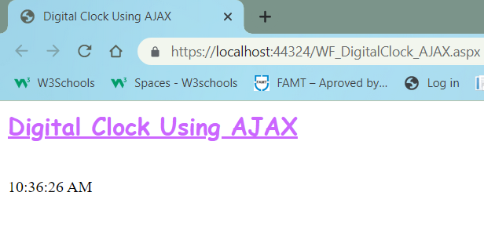

**5. Design an ASP.NET web form using AJAX controls to change the banner image of your college website every 10 seconds.**

**Ans:**

* **CODE –**

WF_BannerChange_AJAX.aspx

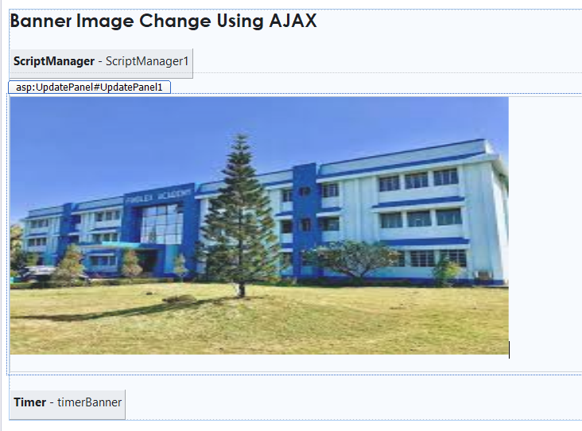

<%@ Page Language="C#" AutoEventWireup="true" CodeBehind="WF_BannerChange_AJAX.aspx.cs" Inherits="PracticalNo4.WF_BannerChange_AJAX" %>

<!DOCTYPE html>

<html xmlns="http://www.w3.org/1999/xhtml">

<head runat="server">

<title>Banner Change</title>

</head>

<body style="height: 79px">

<form id="form1" runat="server">

<div>

<asp:Label ID="Label1" runat="server" Text="Banner Image Change Using AJAX" Font-Bold="True" Font-Names="Century Gothic" Font-Size="Large"></asp:Label>

<br />

<br />

<asp:ScriptManager ID="ScriptManager1" runat="server">

</asp:ScriptManager>

<br />

<asp:UpdatePanel ID="UpdatePanel1" runat="server">

<ContentTemplate>

<asp:Image ID="imgBanner" runat="server" Height="325px" ImageUrl="~/Images/banner_1.jpeg" Width="628px" />

<br />

<br />

</ContentTemplate>

<Triggers>

<asp:AsyncPostBackTrigger ControlID="timerBanner" EventName="Tick" />

</Triggers>

</asp:UpdatePanel>

<br />

<asp:Timer ID="timerBanner" runat="server" Interval="5000" OnTick="timerBanner_Tick">

</asp:Timer>

</div>

</form>

</body>

</html>

WF_BannerChange_AJAX.aspx.cs

using System;

using System.Collections.Generic;

using System.Linq;

using System.Web;

using System.Web.UI;

using System.Web.UI.WebControls;

namespace PracticalNo4

{

public partial class WF_BannerChange_AJAX : System.Web.UI.Page

{

protected void Page_Load(object sender, EventArgs e)

{

}

protected void timerBanner_Tick(object sender, EventArgs e)

{

Random RandomNumber = new Random();

int n = RandomNumber.Next(1,5);

imgBanner.ImageUrl = String.Concat("Images/banner_", n.ToString(), ".jpeg");

}

}

}

* **OUTPUT :**

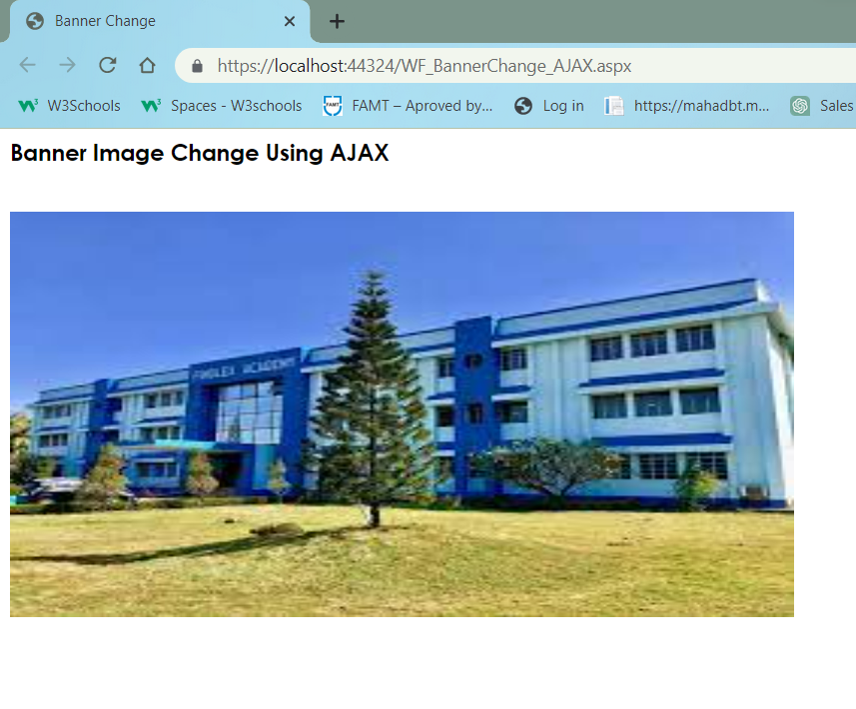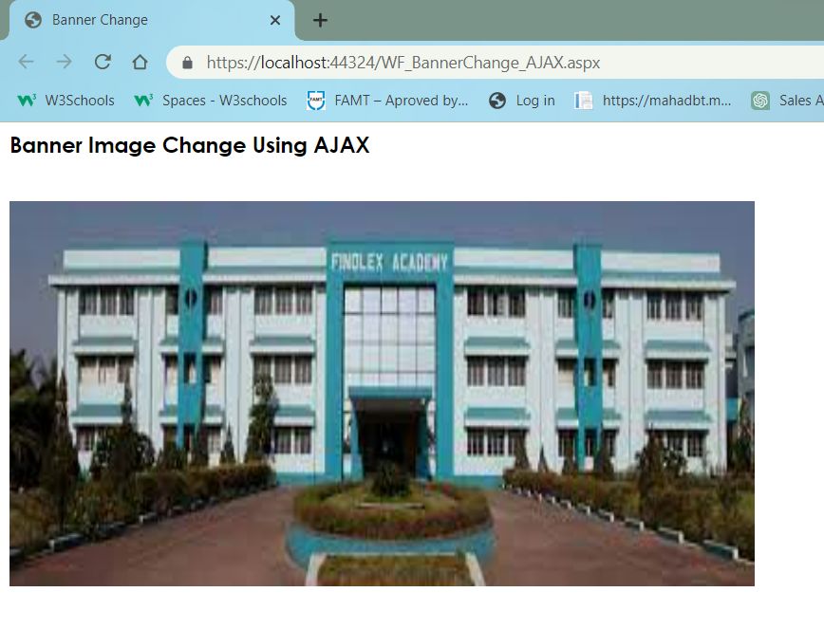

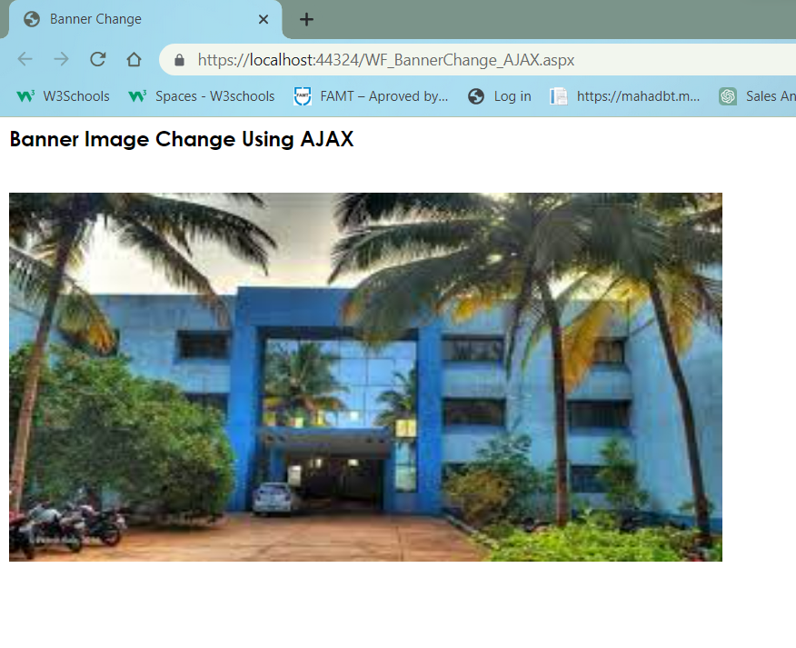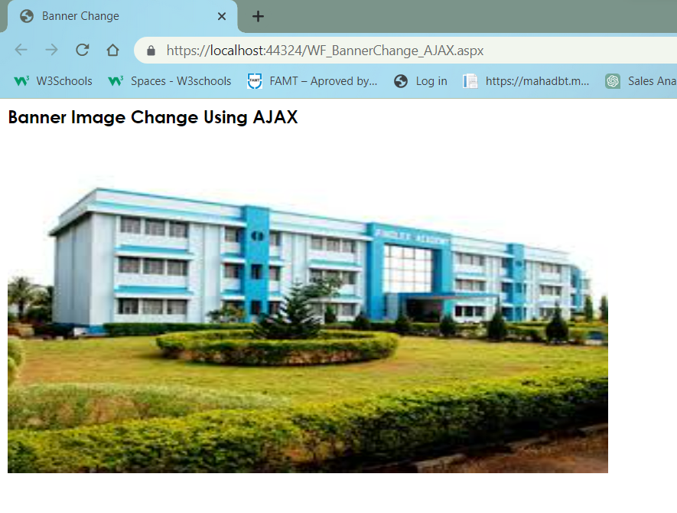

**6. Design an ASP.NET web form to demonstrate UpdatePanel and UpdateProgress AJAX controls.**

**Ans:**

* **CODE –**

**WF_UpdateProgress.aspx**

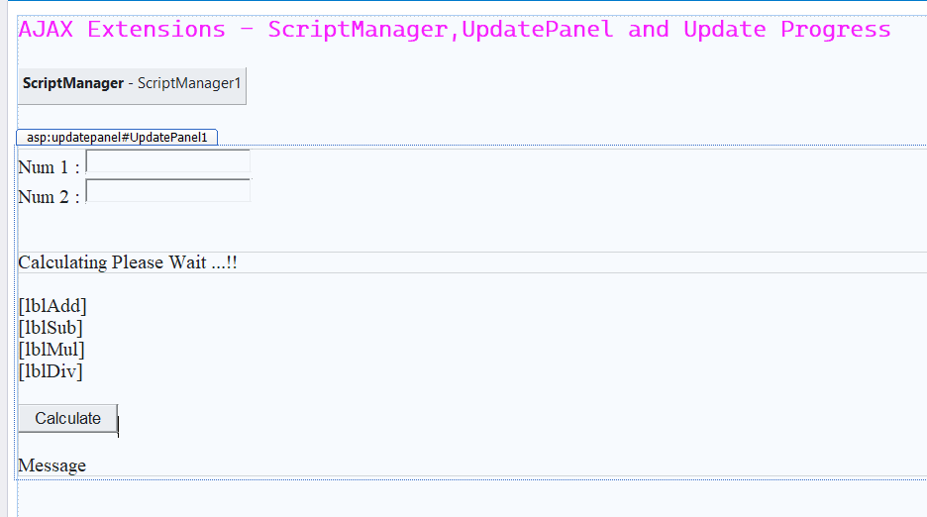

<%@ Page Language="C#" AutoEventWireup="true" CodeBehind="WF_UpdateProgress.aspx.cs" Inherits="PracticalNo4.WF_UpdateProgress" %>

<!DOCTYPE html>

<html xmlns="http://www.w3.org/1999/xhtml">

<head runat="server">

<title>UPDATE PROGRESS USING AJAX</title>

</head>

<body>

<form id="form1" runat="server">

<div>

<asp:Label ID="Label1" runat="server" Font-Bold="True" Font-Names="Cascadia Mono Light" Font-Size="Large" ForeColor="Fuchsia" Text="AJAX Extensions - ScriptManager,UpdatePanel and Update Progress"></asp:Label>

<br />

<asp:ScriptManager ID="ScriptManager1" runat="server">

</asp:ScriptManager>

<br />

<asp:UpdatePanel ID="UpdatePanel1" runat="server">

<ContentTemplate>

<asp:Label ID="Label2" runat="server" Text="Num 1 :"></asp:Label>

&nbsp;<asp:TextBox ID="txtNum1" runat="server"></asp:TextBox>

<br />

<asp:Label ID="Label3" runat="server" Text="Num 2 : "></asp:Label>

<asp:TextBox ID="txtNum2" runat="server"></asp:TextBox>

<br />

<br />

<asp:UpdateProgress ID="UpdateProgress1" runat="server" AssociatedUpdatePanelID="UpdatePanel1">

<ProgressTemplate>

<asp:Label ID="Label4" runat="server" Text="Calculating Please Wait ...!!"></asp:Label>

</ProgressTemplate>

</asp:UpdateProgress>

<br />

<asp:Label ID="lblAdd" runat="server"></asp:Label>

<br />

<asp:Label ID="lblSub" runat="server"></asp:Label>

<br />

<asp:Label ID="lblMul" runat="server"></asp:Label>

<br />

<asp:Label ID="lblDiv" runat="server"></asp:Label>

<br />

<br />

<asp:Button ID="btnCalculate" runat="server" OnClick="btnCalculate_Click" Text="Calculate" />

<br />

<br />

<asp:Label ID="lblmessage" runat="server" Text="Message"></asp:Label>

</ContentTemplate>

<Triggers>

<asp:AsyncPostBackTrigger ControlID="btnCalculate" EventName="Click" />

</Triggers>

</asp:UpdatePanel>

<br />

</div>

</form>

</body>

</html>

**WF_UpdateProgress.aspx.cs**

using System;

using System.Collections.Generic;

using System.Linq;

using System.Web;

using System.Web.UI;

using System.Web.UI.WebControls;

namespace PracticalNo4

{

public partial class WF_UpdateProgress : System.Web.UI.Page

{

protected void Page_Load(object sender, EventArgs e)

{

}

protected void btnCalculate_Click(object sender, EventArgs e)

{

try {

int num1 = Convert.ToInt32(txtNum1.Text);

int num2 = Convert.ToInt32(txtNum2.Text);

System.Threading.Thread.Sleep(5000);

int add = num1 + num2;

int sub = num1 - num2;

int mul = num1 * num2;

int div = num1 / num2;

lblAdd.Text = string.Format("Addition:{0}",add);

lblSub.Text = string.Format("Substraction:{0}", sub);

lblMul.Text = string.Format("Multiplication:{0}", mul);

lblDiv.Text = string.Format("Division:{0}", div);

}

catch(Exception ex)

{

lblmessage.Text = "Exception Caught!!" + ex.Message;

}

}

}

}

* **OUTPUT :**

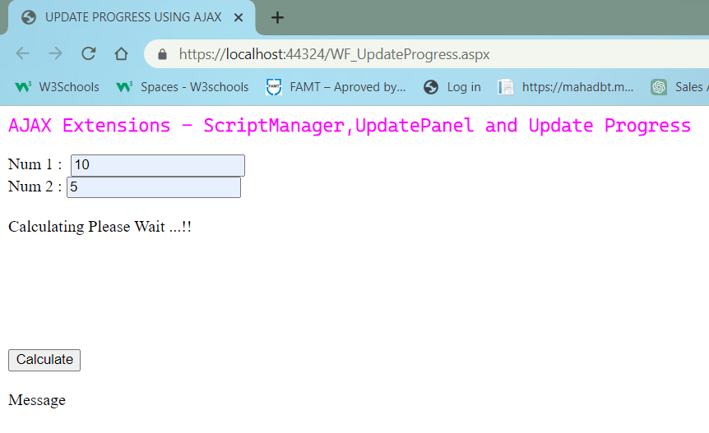

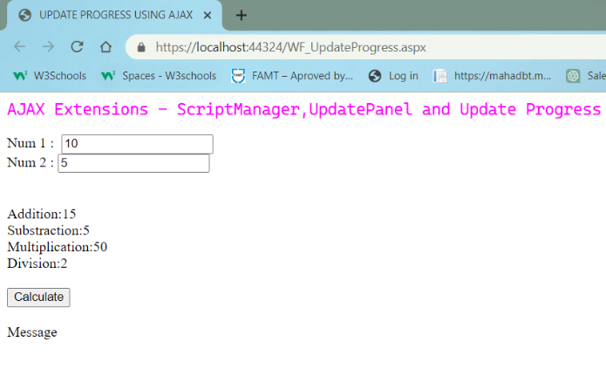

**7. Design an ASP.NET web form to show paginated output of customer_info table in GridView using AJAX.**

**Ans:**

* **CODE –**

WF_Pagination_AJAX.aspx

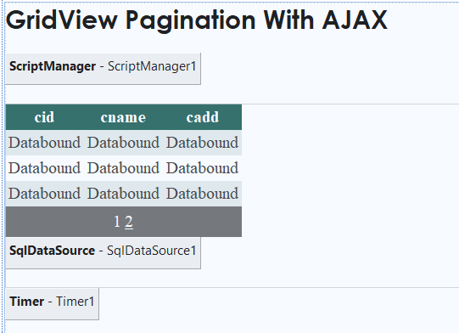

<%@ Page Language="C#" AutoEventWireup="true" CodeBehind="WF_Pagination_AJAX.aspx.cs" Inherits="PracticalNo4.WF_Pagination_AJAX" %>

<!DOCTYPE html>

<html xmlns="http://www.w3.org/1999/xhtml">

<head runat="server">

<title>Pagination </title>

</head>

<body>

<form id="form1" runat="server">

<div style="height: 730px">

<asp:Label ID="Label1" runat="server" Text="GridView Pagination With AJAX " Font-Bold="True" Font-Names="Century Gothic" Font-Size="X-Large"></asp:Label>

<br />

<br />

<asp:ScriptManager ID="ScriptManager1" runat="server">

</asp:ScriptManager>

<br />

<asp:UpdatePanel ID="UpdatePanel1" runat="server">

<ContentTemplate>

<asp:GridView ID="GridView1" runat="server" AllowPaging="True" AutoGenerateColumns="False" CellPadding="4" DataKeyNames="cid" DataSourceID="SqlDataSource1" ForeColor="#333333" GridLines="None" PageSize="3">

<AlternatingRowStyle BackColor="White" />

<Columns>

<asp:BoundField DataField="cid" HeaderText="cid" ReadOnly="True" SortExpression="cid" />

<asp:BoundField DataField="cname" HeaderText="cname" SortExpression="cname" />

<asp:BoundField DataField="cadd" HeaderText="cadd" SortExpression="cadd" />

</Columns>

<EditRowStyle BackColor="#7C6F57" />

<FooterStyle BackColor="#1C5E55" Font-Bold="True" ForeColor="White" />

<HeaderStyle BackColor="#1C5E55" Font-Bold="True" ForeColor="White" />

<PagerStyle BackColor="#666666" ForeColor="White" HorizontalAlign="Center" />

<RowStyle BackColor="#E3EAEB" />

<SelectedRowStyle BackColor="#C5BBAF" Font-Bold="True" ForeColor="#333333" />

<SortedAscendingCellStyle BackColor="#F8FAFA" />

<SortedAscendingHeaderStyle BackColor="#246B61" />

<SortedDescendingCellStyle BackColor="#D4DFE1" />

<SortedDescendingHeaderStyle BackColor="#15524A" />

</asp:GridView>

<asp:SqlDataSource ID="SqlDataSource1" runat="server" ConnectionString="<%$ ConnectionStrings:customerConString %>" SelectCommand="SELECT * FROM [cust]"></asp:SqlDataSource>

<br />

</ContentTemplate>

<Triggers>

<asp:AsyncPostBackTrigger ControlID="Timer1" EventName="Tick" />

</Triggers>

</asp:UpdatePanel>

<asp:Timer ID="Timer1" runat="server" Interval="2000" OnTick="Timer1_Tick">

</asp:Timer>

<br />

</div>

</form>

</body>

</html>

WF_Pagination_AJAX.aspx.cs

using System;

using System.Collections.Generic;

using System.Linq;

using System.Web;

using System.Web.UI;

using System.Web.UI.WebControls;

namespace PracticalNo4

{

public partial class WF_Pagination_AJAX : System.Web.UI.Page

{

protected void Page_Load(object sender, EventArgs e)

{

}

protected void Timer1_Tick(object sender, EventArgs e)

{

if (GridView1.PageIndex != GridView1.PageCount - 1)

{

GridView1.PageIndex = GridView1.PageIndex + 1;

}

else

{

GridView1.PageIndex = 0;

}

}

}

}

* **OUTPUT :**



